Hey guys!

My name is Brigitta. I was trying to use streamlit to build a website for our small project on eye disease classification. BUT, it failed so many times. Until now, it is still unfixed. Now, let me walk you through what happened and what could be the potential issue.

Firstly, we are initially using sequential models for our EfficientNetB5, InceptionV3, and DenseNet201. However, we have a message that sequential cannot be use. So we turn into functional.

However, this might be wrong based on this article: <https://blog.streamlit.io/deep-learning-apps-for-image-processing-made-easy-a-step-by-step-guide/>

I will try it out tmr to download my sequential model and load it, and download it in keras 2.14 so that my mac can run on it. 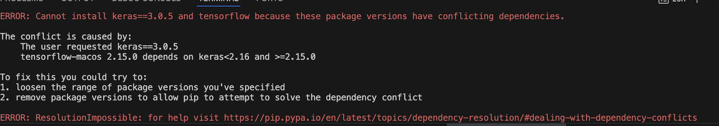

Secondly, the issue up there. Okay, this is an issue because we have CNN models we input into the website to predict a new image. However, because of the keras files are downloaded at keras==3.0.5, so it crash as my M2 chip is only 2.15.

You would say, oh it is pretty easy to fix! Just bypass it. Not at all! We are not able to bypass the Mac itself. So now, my teammate cheech is trying to redownloaded his keras file😊 I hope this could work.

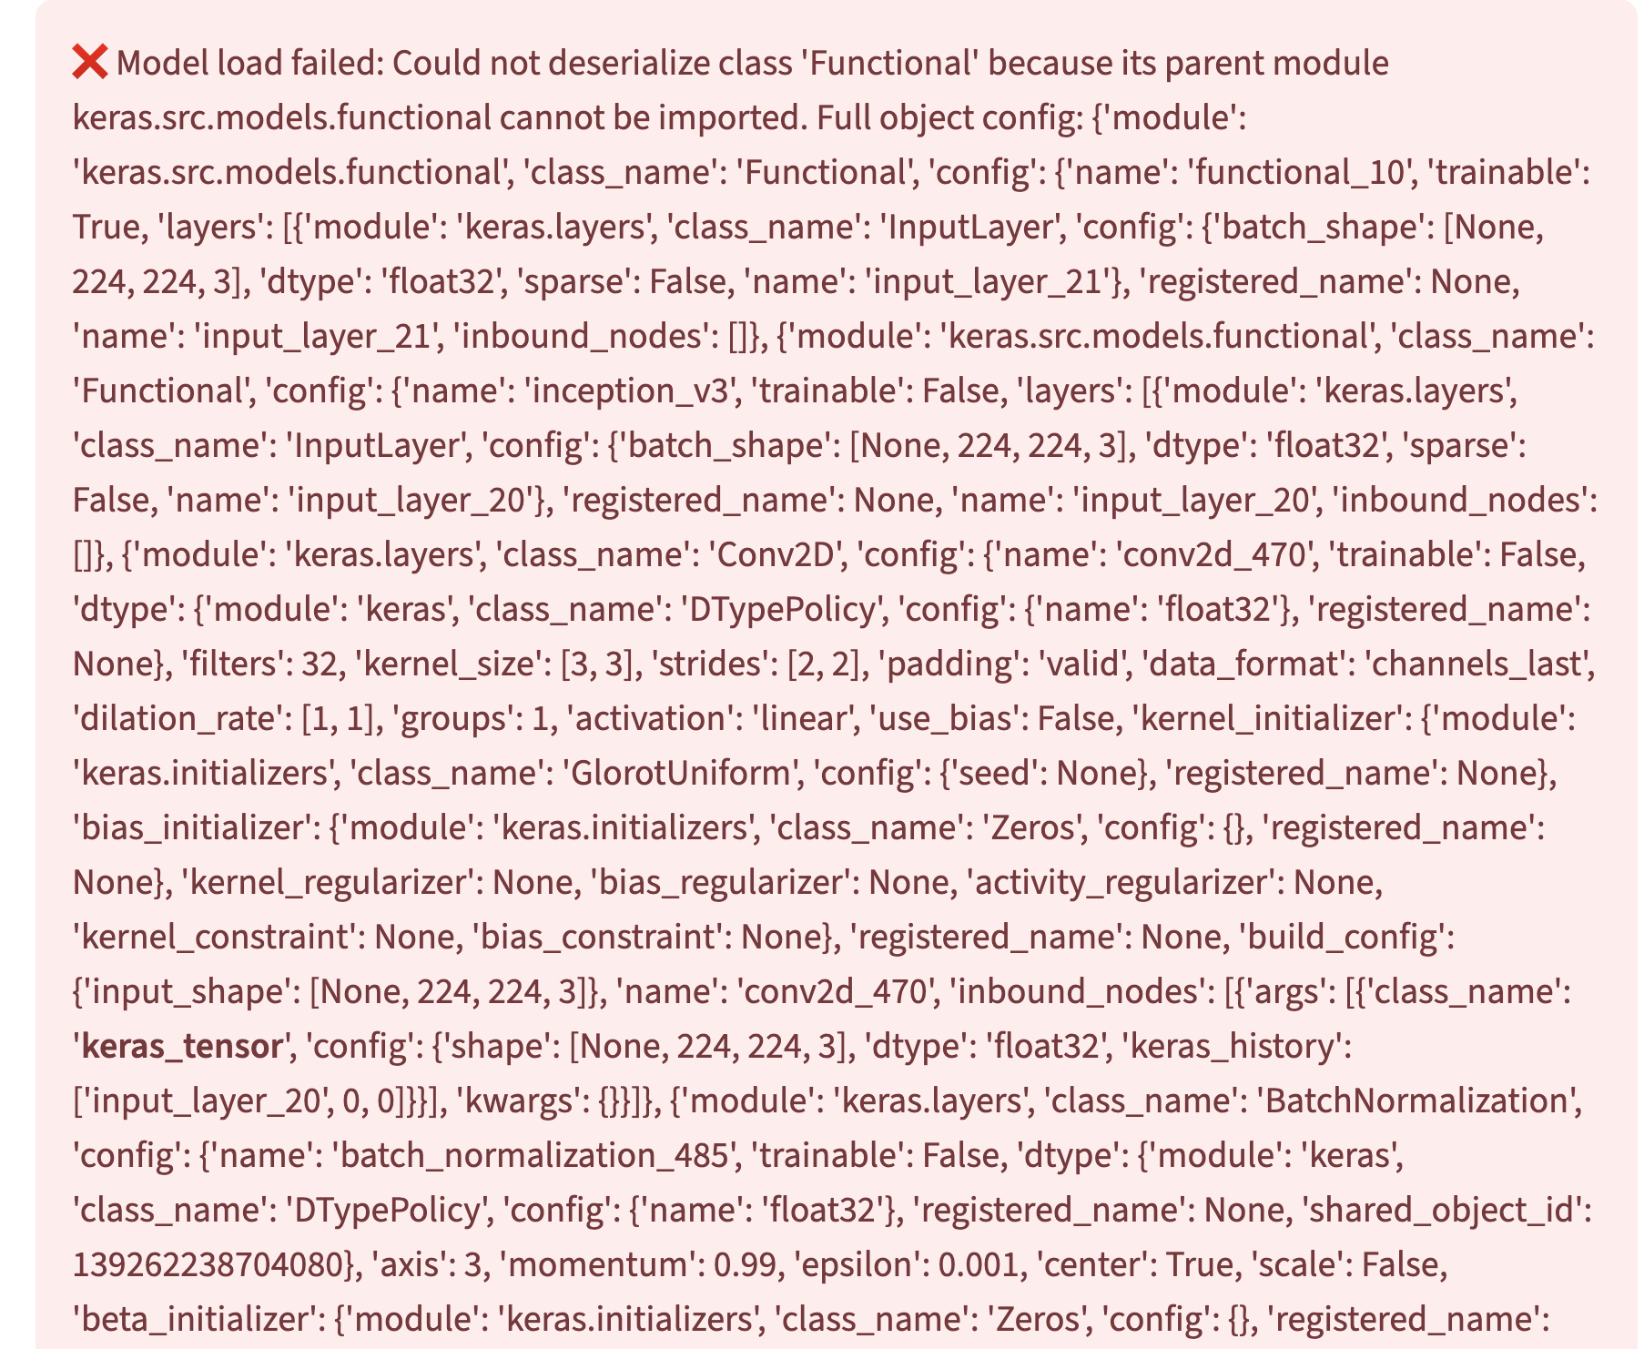

This is the error we have when the keras are incompatible. Interesting, right?